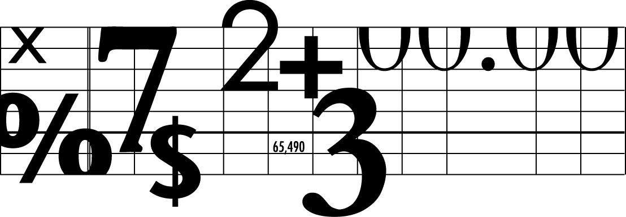
Name:
Phone:
Fax:
Address:
To:
Fax #:
# of pages:
Messages:

FAX

